**WITH NOISE AND WITHOUT FILTER**

**Image set:**

|  |
| --- |
| **Image 1:-0.1 % Noise** |

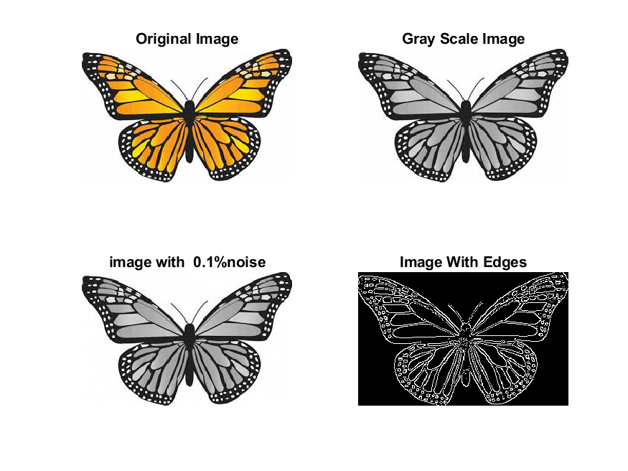

**Image 2:-10 % Noise**

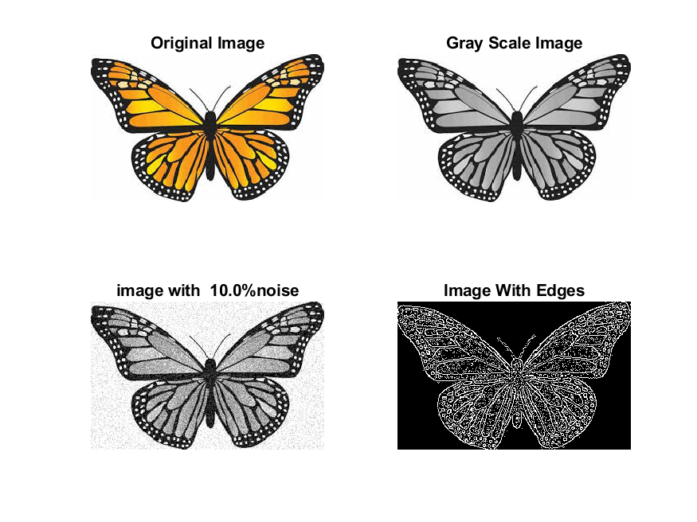

**Image 3:-20 % Noise**

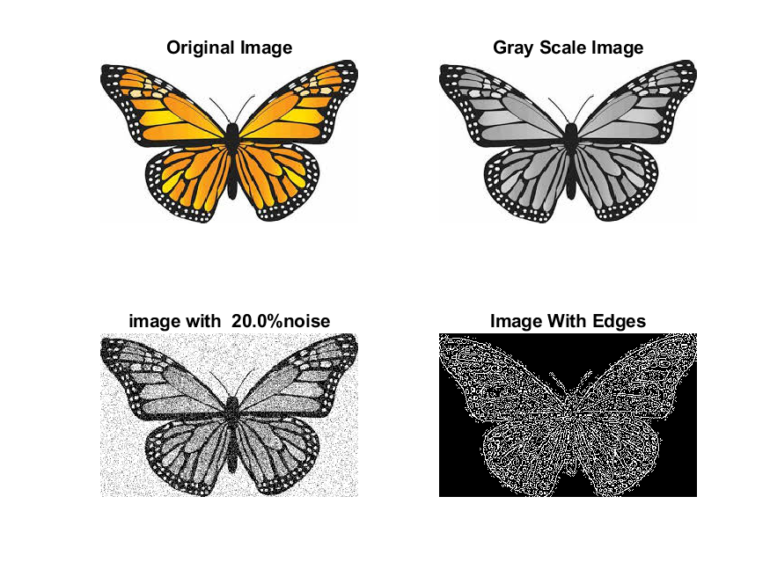

**Image 4:-30 % Noise**

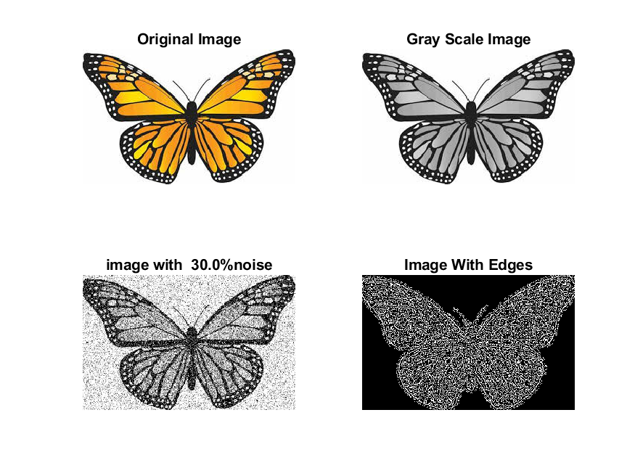

|  |
| --- |
| **Image 5:-40 % Noise** |

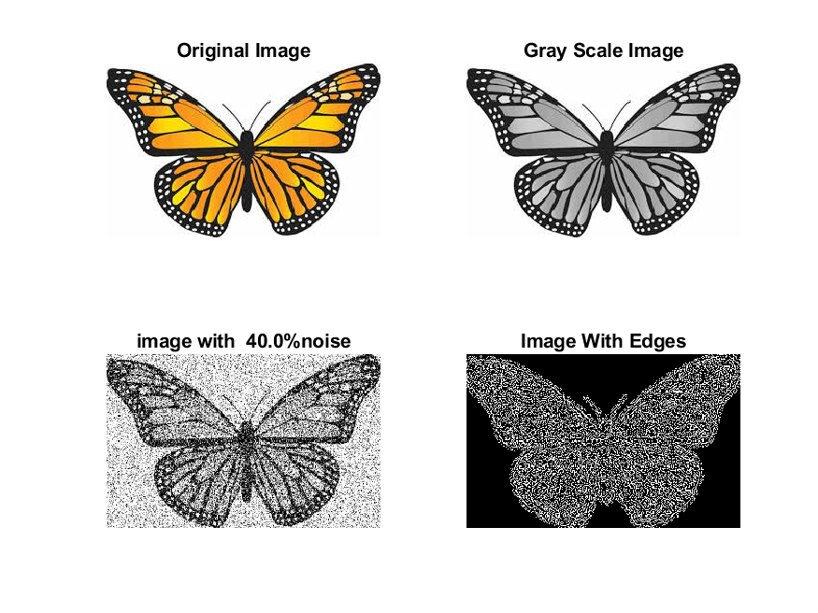

**Image 6:-50 % Noise**

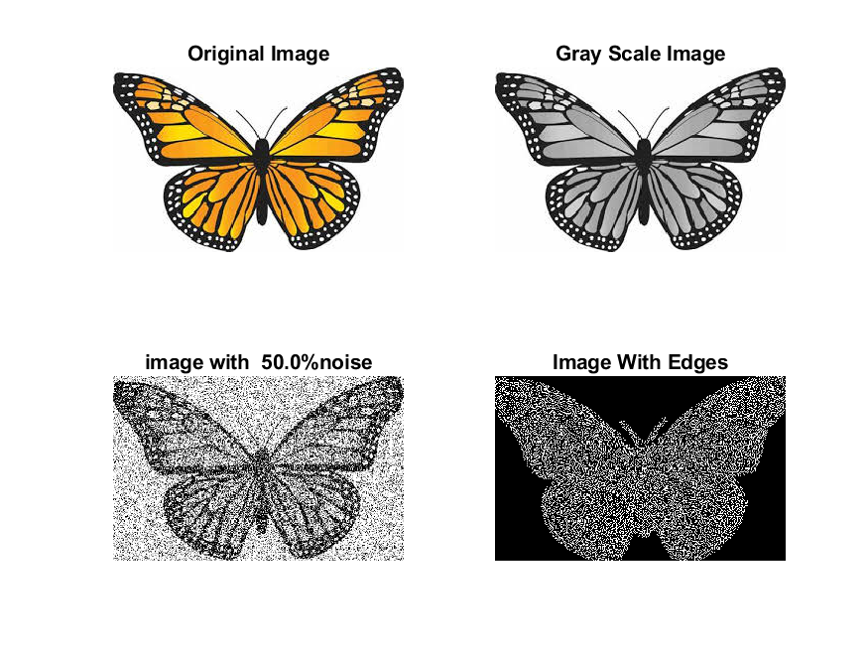

**Image 7:-60 % Noise**

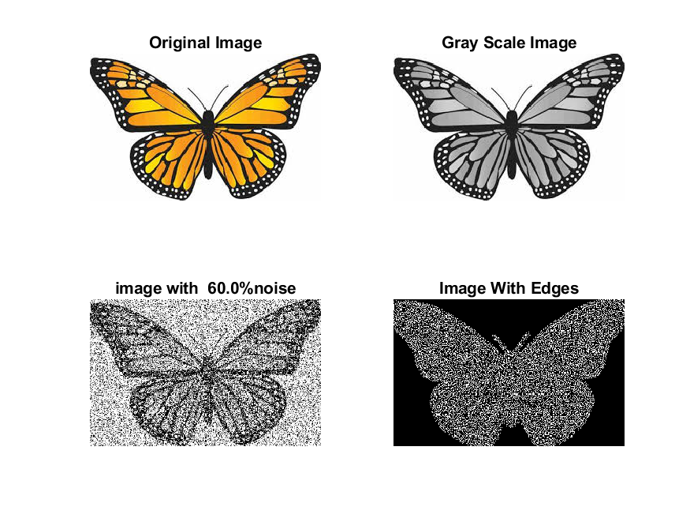

**Image 8:-70 % Noise**

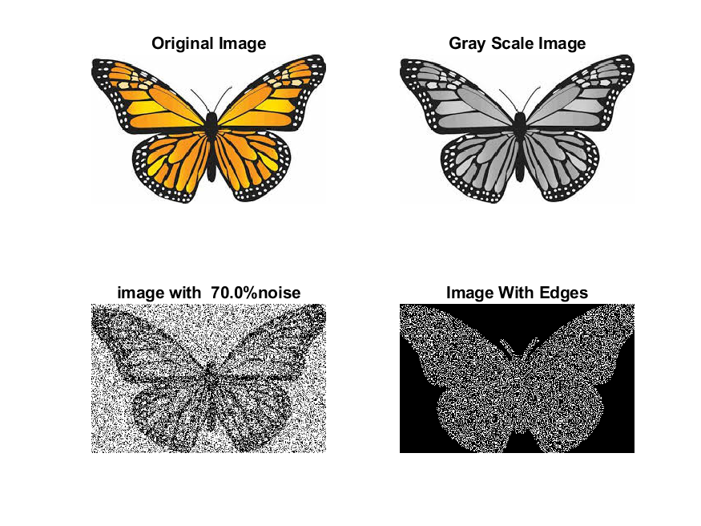

**Image 9:-80 % Noise**

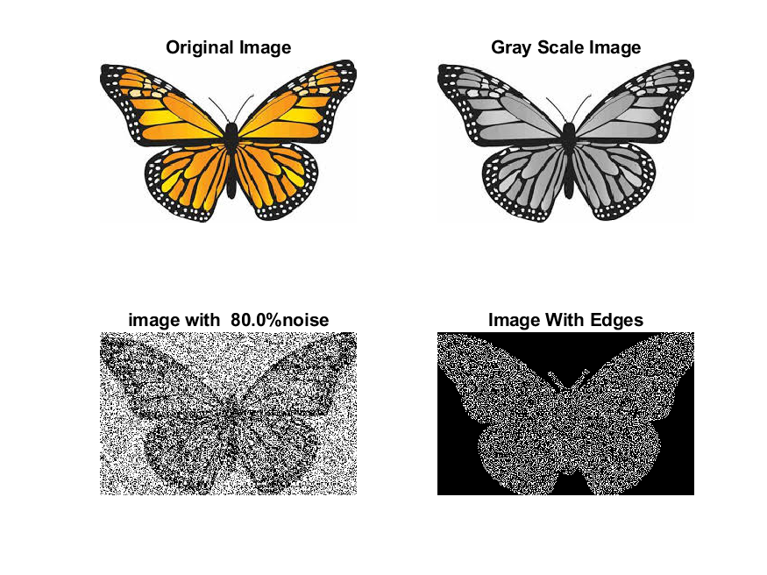

**DATA FILES**

**Image 1:-Noise0.1**

Original image ideal values:

IM1 image entropy:5.725024e-01

IM1 image mean:0.135564

Ground truth image entropy:0.968631

Ground truth image mean:0.396113

entropy between imt and im1 :0.892551

MSE between imt and im1 :0.358374

Average Difference between imt and im1 :0.260549

Maximum Difference between imt and im1 :1.000000

True Positive values:4374.000000

False Positive values: 2469.000000

True Negative values:28014.000000

False Negative values:15621.000000

Accuracy value: 0.641626

F Measure values:0.325956

Peak Signal-to Noise Ration value: 4.456636

Signal-to Noise Ration value: -4.656749

percentage of pixels that were correctly detected (Pco): 0.218755

The percentage of pixels that were not detected (Pnd):0.781245

the percentage of false alarm: (Pfa):0.123481

Euclidean Distance Value :20.906477

**Image 2:-Noise10**

Original image ideal values:

IM1 image entropy:6.945487e-01

IM1 image mean:0.186715

Ground truth image entropy:0.968631

Ground truth image mean:0.396113

entropy between imt and im1 :0.859313

MSE between imt and im1 :0.356314

Average Difference between imt and im1 :0.209398

Maximum Difference between imt and im1 :1.000000

True Positive values:5717.000000

False Positive values: 3708.000000

True Negative values:26775.000000

False Negative values:14278.000000

Accuracy value: 0.643686

F Measure values:0.388647

Peak Signal-to Noise Ration value: 4.481676

Signal-to Noise Ration value: -3.266400

percentage of pixels that were correctly detected (Pco): 0.285921

The percentage of pixels that were not detected (Pnd):0.714079

the percentage of false alarm: (Pfa):0.185446

Euclidean Distance Value :27.613167

**Image 3:-Noise20**

Original image ideal values:

IM1 image entropy:7.497173e-01

IM1 image mean:0.214351

Ground truth image entropy:0.968631

Ground truth image mean:0.396113

entropy between imt and im1 :0.839724

MSE between imt and im1 :0.355818

Average Difference between imt and im1 :0.181762

Maximum Difference between imt and im1 :1.000000

True Positive values:6427.000000

False Positive values: 4393.000000

True Negative values:26090.000000

False Negative values:13568.000000

Accuracy value: 0.644182

F Measure values:0.417135

Peak Signal-to Noise Ration value: 4.487716

Signal-to Noise Ration value: -2.666941

percentage of pixels that were correctly detected (Pco): 0.321430

The percentage of pixels that were not detected (Pnd):0.678570

the percentage of false alarm: (Pfa):0.219705

Euclidean Distance Value :31.162163

**Image 4:-Noise30**

Original image ideal values:

IM1 image entropy:7.616781e-01

IM1 image mean:0.220829

Ground truth image entropy:0.968631

Ground truth image mean:0.396113

entropy between imt and im1 :0.836878

MSE between imt and im1 :0.358374

Average Difference between imt and im1 :0.175284

Maximum Difference between imt and im1 :1.000000

True Positive values:6526.000000

False Positive values: 4621.000000

True Negative values:25862.000000

False Negative values:13469.000000

Accuracy value: 0.641626

F Measure values:0.419112

Peak Signal-to Noise Ration value: 4.456636

Signal-to Noise Ration value: -2.537634

percentage of pixels that were correctly detected (Pco): 0.326382

The percentage of pixels that were not detected (Pnd):0.673618

the percentage of false alarm: (Pfa):0.231108

Euclidean Distance Value :31.655973

**Image 4:-Noise30**

Original image ideal values:

IM1 image entropy:7.653367e-01

IM1 image mean:0.222850

Ground truth image entropy:0.968631

Ground truth image mean:0.396113

entropy between imt and im1 :0.831601

MSE between imt and im1 :0.353223

Average Difference between imt and im1 :0.173264

Maximum Difference between imt and im1 :1.000000

True Positive values:6707.000000

False Positive values: 4542.000000

True Negative values:25941.000000

False Negative values:13288.000000

Accuracy value: 0.646777

F Measure values:0.429330

Peak Signal-to Noise Ration value: 4.519508

Signal-to Noise Ration value: -2.498075

percentage of pixels that were correctly detected (Pco): 0.335434

The percentage of pixels that were not detected (Pnd):0.664566

the percentage of false alarm: (Pfa):0.227157

Euclidean Distance Value :32.560378

**Image 5:-Noise40**

Original image ideal values:

IM1 image entropy:7.653367e-01

IM1 image mean:0.222850

Ground truth image entropy:0.968631

Ground truth image mean:0.396113

entropy between imt and im1 :0.831601

MSE between imt and im1 :0.353223

Average Difference between imt and im1 :0.173264

Maximum Difference between imt and im1 :1.000000

True Positive values:6707.000000

False Positive values: 4542.000000

True Negative values:25941.000000

False Negative values:13288.000000

Accuracy value: 0.646777

F Measure values:0.429330

Peak Signal-to Noise Ration value: 4.519508

Signal-to Noise Ration value: -2.498075

percentage of pixels that were correctly detected (Pco): 0.335434

The percentage of pixels that were not detected (Pnd):0.664566

the percentage of false alarm: (Pfa):0.227157

Euclidean Distance Value :32.560378

**Image 6:-Noise50**

Original image ideal values:

IM1 image entropy:7.616421e-01

IM1 image mean:0.220809

Ground truth image entropy:0.968631

Ground truth image mean:0.396113

entropy between imt and im1 :0.835343

MSE between imt and im1 :0.356254

Average Difference between imt and im1 :0.175304

Maximum Difference between imt and im1 :1.000000

True Positive values:6579.000000

False Positive values: 4567.000000

True Negative values:25916.000000

False Negative values:13416.000000

Accuracy value: 0.643746

F Measure values:0.422530

Peak Signal-to Noise Ration value: 4.482400

Signal-to Noise Ration value: -2.538024

percentage of pixels that were correctly detected (Pco): 0.329032

The percentage of pixels that were not detected (Pnd):0.670968

the percentage of false alarm: (Pfa):0.228407

Euclidean Distance Value :31.921722

**Image 7:-Noise60**

Original image ideal values:

IM1 image entropy:7.612815e-01

IM1 image mean:0.220611

Ground truth image entropy:0.968631

Ground truth image mean:0.396113

entropy between imt and im1 :0.835517

MSE between imt and im1 :0.356294

Average Difference between imt and im1 :0.175502

Maximum Difference between imt and im1 :1.000000

True Positive values:6573.000000

False Positive values: 4563.000000

True Negative values:25920.000000

False Negative values:13422.000000

Accuracy value: 0.643706

F Measure values:0.422280

Peak Signal-to Noise Ration value: 4.481917

Signal-to Noise Ration value: -2.541922

percentage of pixels that were correctly detected (Pco): 0.328732

The percentage of pixels that were not detected (Pnd):0.671268

the percentage of false alarm: (Pfa):0.228207

Euclidean Distance Value :31.890800

**Image 8:-Noise70**

Original image ideal values:

IM1 image entropy:7.649795e-01

IM1 image mean:0.222651

Ground truth image entropy:0.968631

Ground truth image mean:0.396113

entropy between imt and im1 :0.832834

MSE between imt and im1 :0.354689

Average Difference between imt and im1 :0.173462

Maximum Difference between imt and im1 :1.000000

True Positive values:6665.000000

False Positive values: 4574.000000

True Negative values:25909.000000

False Negative values:13330.000000

Accuracy value: 0.645311

F Measure values:0.426779

Peak Signal-to Noise Ration value: 4.501521

Signal-to Noise Ration value: -2.501937

percentage of pixels that were correctly detected (Pco): 0.333333

The percentage of pixels that were not detected (Pnd):0.666667

the percentage of false alarm: (Pfa):0.228757

Euclidean Distance Value :32.350516

**Image 9:-Noise80**

Original image ideal values:

IM1 image entropy:7.648008e-01

IM1 image mean:0.222552

Ground truth image entropy:0.968631

Ground truth image mean:0.396113

entropy between imt and im1 :0.829535

MSE between imt and im1 :0.350153

Average Difference between imt and im1 :0.173561

Maximum Difference between imt and im1 :1.000000

True Positive values:6777.000000

False Positive values: 4457.000000

True Negative values:26026.000000

False Negative values:13218.000000

Accuracy value: 0.649847

F Measure values:0.434020

Peak Signal-to Noise Ration value: 4.557427

Signal-to Noise Ration value: -2.503870

percentage of pixels that were correctly detected (Pco): 0.338935

The percentage of pixels that were not detected (Pnd):0.661065

the percentage of false alarm: (Pfa):0.222906

Euclidean Distance Value :32.911082